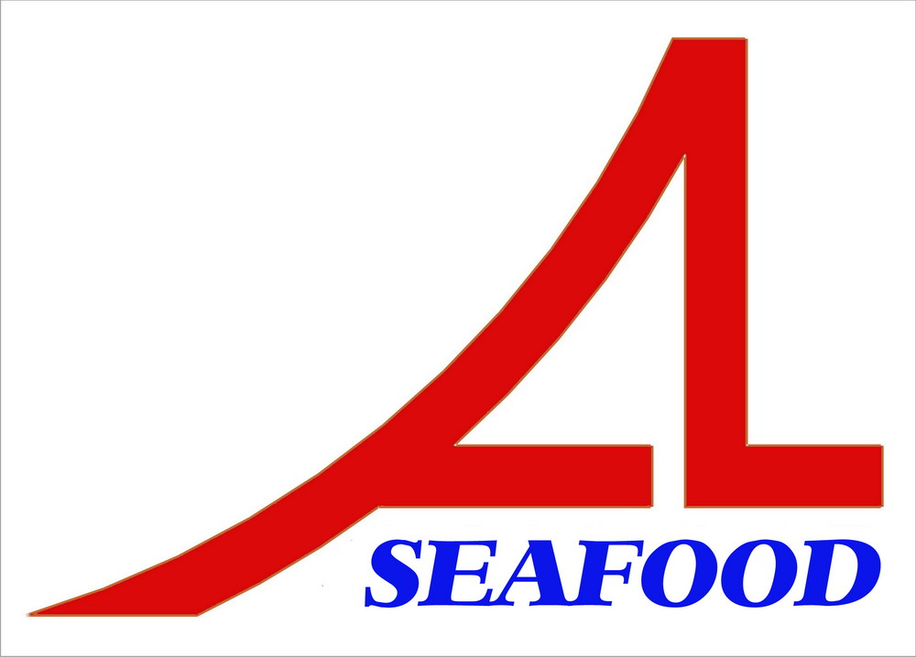AN LAC SEAFOOD CO.,LTD
LOT A14,4A STREET,HAISON INDUSTRIAL ZONE,DUC HOA DISTRICT,LONG AN PROVINCE,VIETNAM

AGREEMENT
Date : 02/01/2013
Party A : AN LAC SEAFOOD CO., LTD.

Address: Lot A14, 4A Street, Hai Son Industrial Zone, Duc Hoa District, Long An Province, Vietnam.

Tel/ Fax: 84-72-3850606 / 84-72-3850608
Represented by: Mr. NGUYEN THIEN DUY – Director

Party B : Ms. CHANG SU JUNG

After discussion , it is must be mutually agreed by both parties to sign for agreement as follow :
After comparing , two parties agree with the prepayment : 30.000,00 USD (base on the advice of bank No.: 121220-2 dated : 20/9/2012 ) will be paid to contract No.: 01/AL-YY/12 amuont 11.092,00 USD and contract No. : 01/AL/13 amount 3.496,80 USD.
The agreement have valid from the date was signed .
The agreement is made into 02 (two) originals in English , each party keeps 01 (one) original with equal value .
PARTY A PARTY B

Nguyễn Thiện Duy Chang Su Jung

